Bahria University,

Karachi Campus



LAB EXPERIMENT NO.

___13____

LIST OF TASKS

|  |  |
| --- | --- |
| TASK NO | OBJECTIVE |
| 01 | **Example 1:**  **𝐹 = 𝐴𝐵C + A𝐵𝐶’ + A𝐵’C** |
| 02 | **Example 2:**  **𝐹 = 𝐴𝐵̅’ + 𝐵̅’𝐶 + 𝐵𝐶̅’** |
| 03 | **𝐹 (𝐴, 𝐵, 𝐶,𝐷) = ∑(0,1,2,5,8,9,10):** |
| 04 | **𝐹 (𝐴, 𝐵, 𝐶,𝐷) = ∑(1, 3, 7, 11, 15):** |

Submitted On:

__January 9th’2023__

(Date: DD/MM/YY)

**Example 1:**

**𝐹 = 𝐴𝐵C + A𝐵𝐶’ + A𝐵’C**

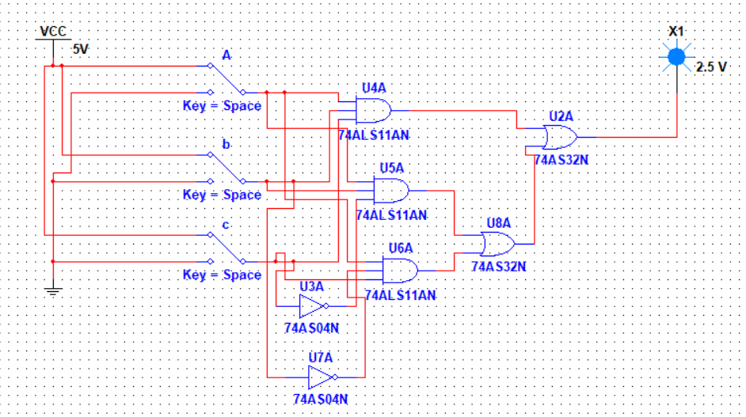

**Example 2:**

**𝐹 = 𝐴𝐵̅’ + 𝐵̅’𝐶 + 𝐵𝐶̅’**

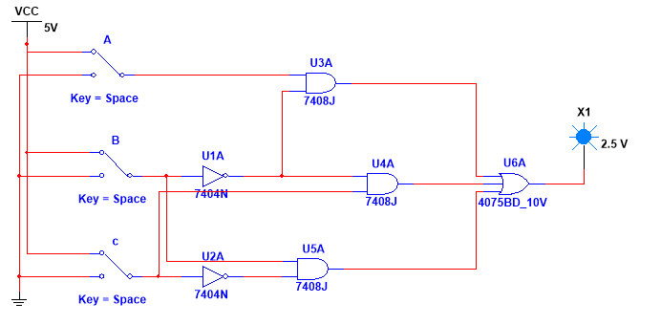

**Question:**

**𝐹 (𝐴, 𝐵, 𝐶,𝐷) = ∑(0,1,2,5,8,9,10):**

**After K-Map:**

**𝐹 = A’B’D’ + A’C’D + AB’C’ + B’CD’**

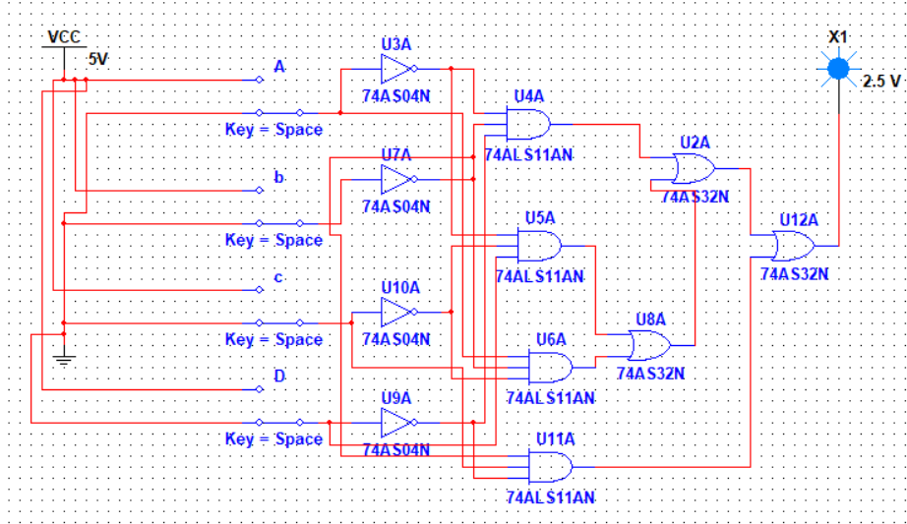

**Question:**

**𝐹 (𝐴, 𝐵, 𝐶,𝐷) = ∑(1, 3, 7, 11, 15):**

**After K-Map:**

**𝐹 = A’B’D + A’CD + B’CD**

